Pizza Dough
serves 5

1 ½ cups of all-purpose flour
⅔ teaspoon of white sugar
⅓ teaspoon of yeast
⅔ cups of water
3 tablespoons of olive oil
½ teaspoon of salt


Carrot Cake
serves 20 people

2 cups of all-purpose flour
⅔ cup of white sugar
¾ cup of brown sugar
2 teaspoons of ground cinnamon
2 ½ teaspoons of baking soda
1 ½ pounds of grated carrots
4 eggs
⅓ cup of lemon juice


Fudge Cupcakes
serves 10

1 ⅔ cups of all-purpose flour
¾ cups of white sugar
1 ¼ teaspoon of baking soda
2 eggs
½ stick of butter
½ teaspoon of vanilla essence
1 tablespoon of maple syrup
¾ cup of chopped fudge


Gingerbread Cookies
serves 8

2 cups of all-purpose flour
¾ cup of white sugar
⅔ cup of brown sugar
1 ½ teaspoon of baking soda
1 ¼ teaspoon of ground ginger
¾ tablespoon of cinnamon
½ cup of maple syrup

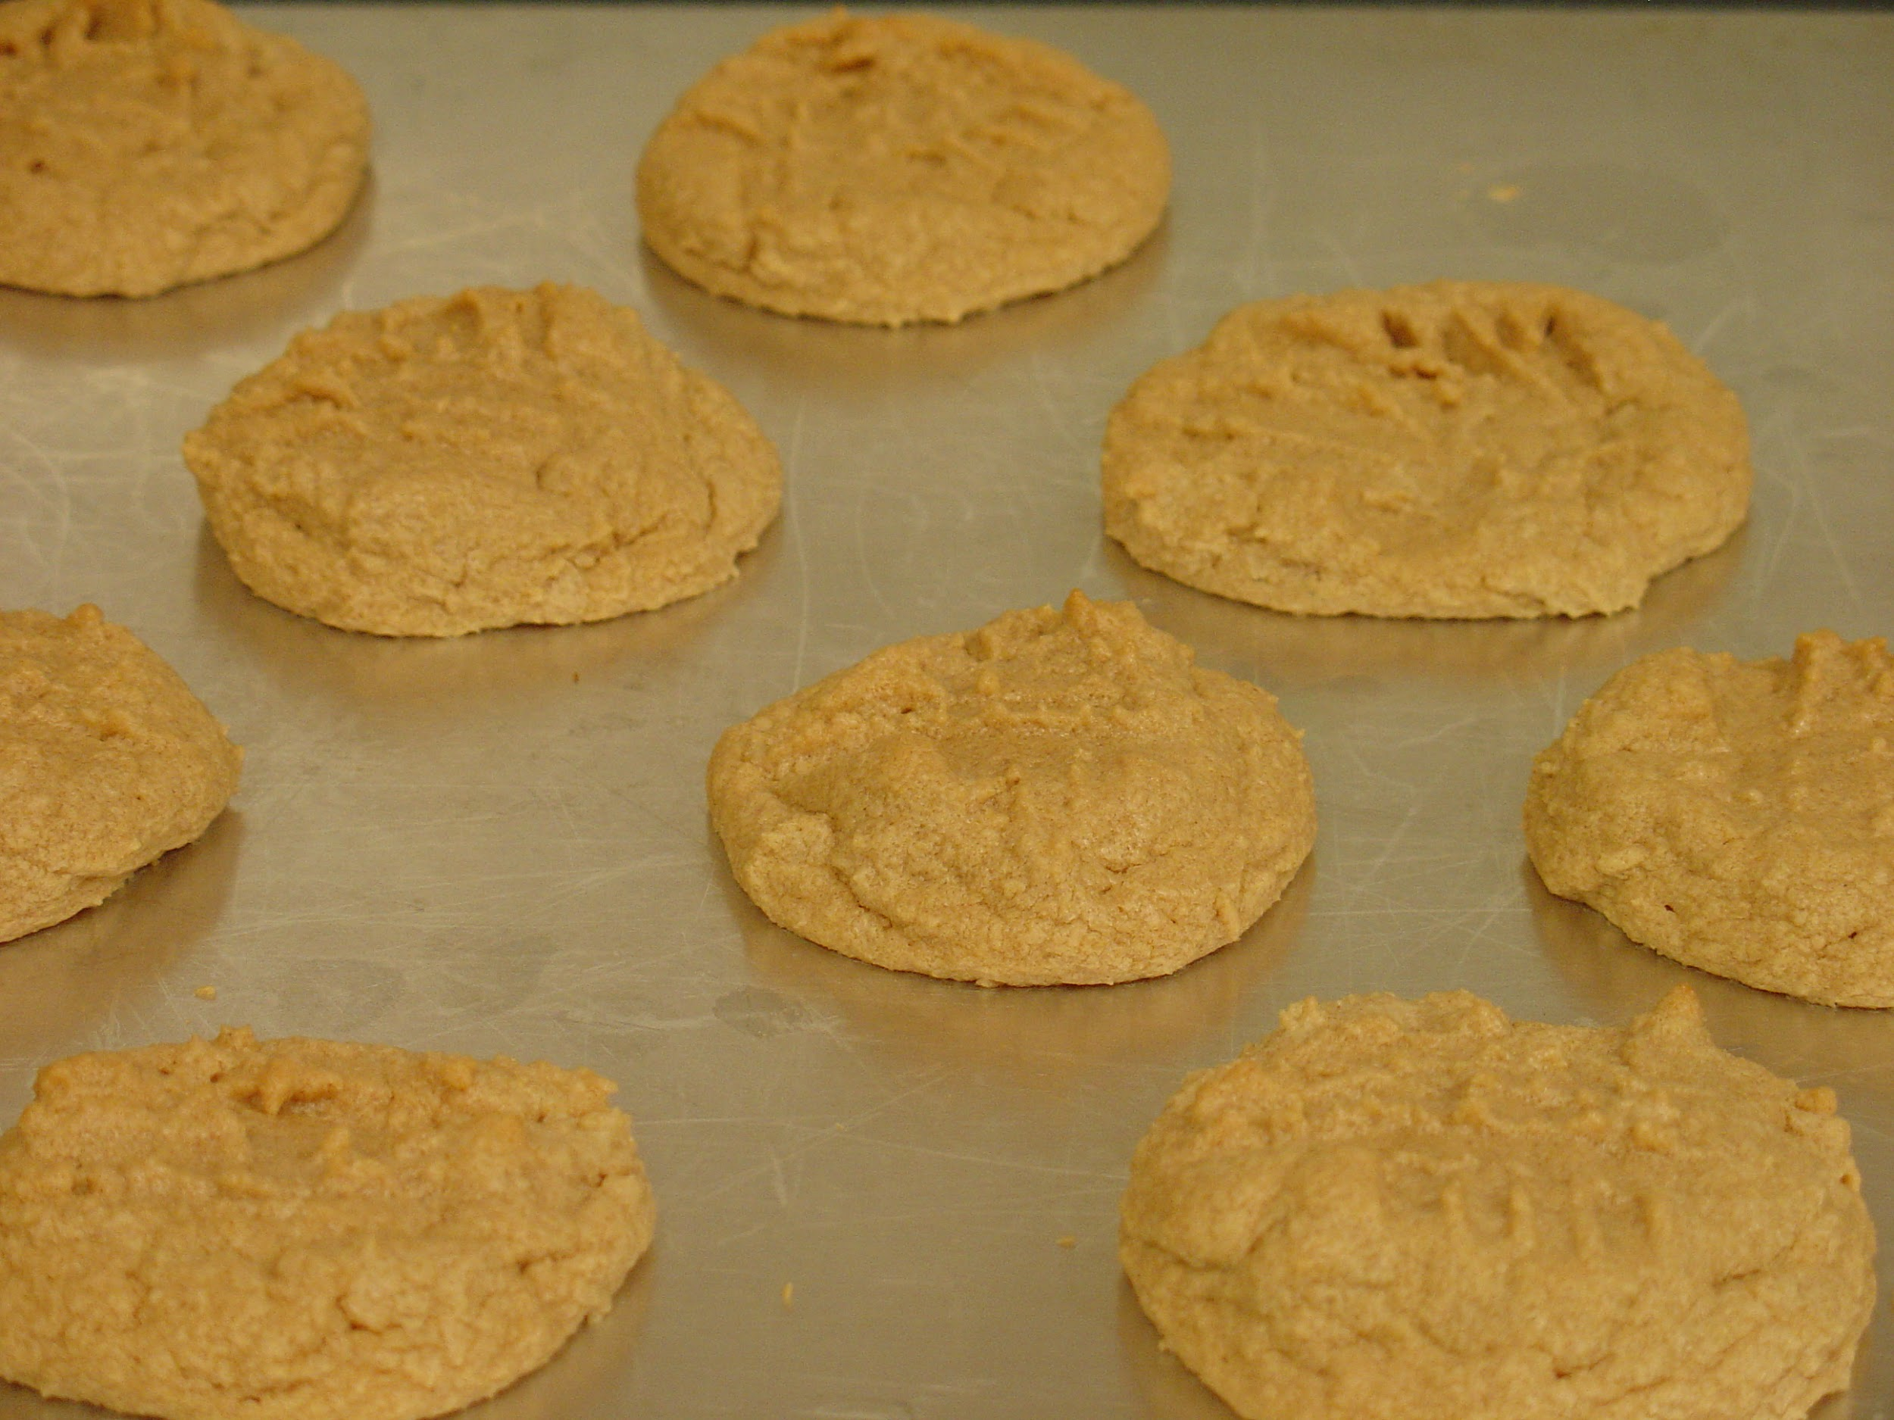
Peanut Butter Cookies
serves 8 people

1 cup of all-purpose flour
½ cup of white sugar
¼ cup of brown sugar
⅔ stick of butter
½ cup of peanut butter
1 egg
¾ teaspoon of baking soda
⅛ teaspoon of salt

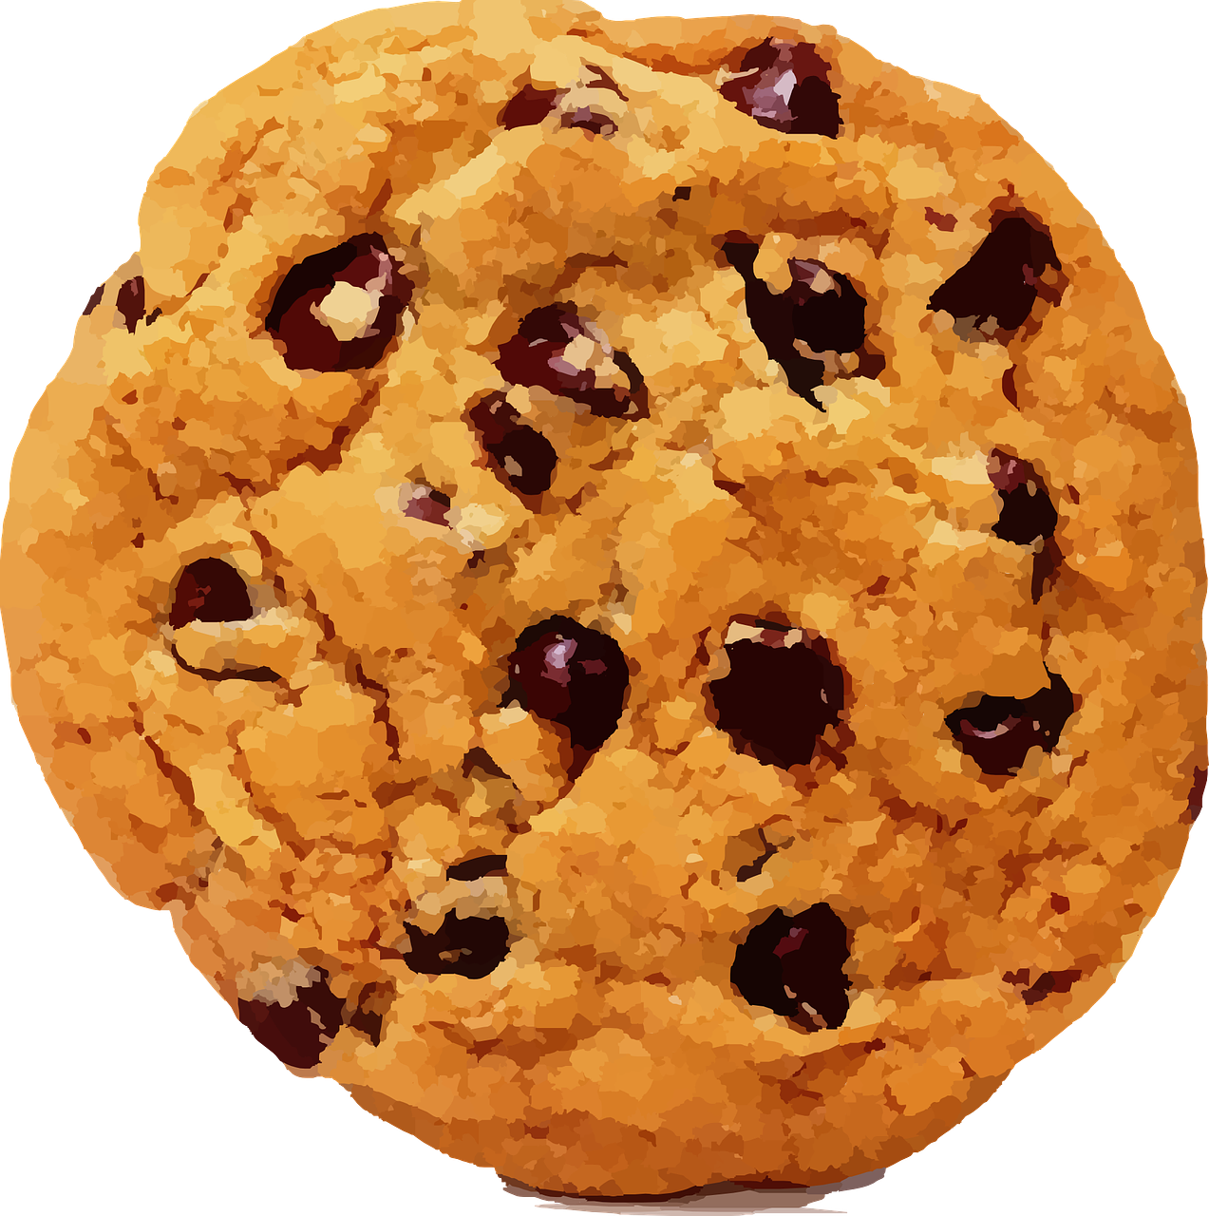
Chocolate Chip Cookies
serves 10 people

1 ¾ cups of all-purpose flour
⅓ cup of white sugar
⅜ cup of brown sugar
½ teaspoon of baking soda
¾ stick of butter
1 large egg
⅔ bag of chocolate chips
⅓ teaspoon of salt

Group Task

There are six baking recipes that your class has to increase to serve more people.

The recipes are for:

- Pizza Dough – serves 5 people
- Carrot Cake – serves 20 people
- Fudge Cupcakes – serves 10 people
- Gingerbread Cookies – serves 8 people
- Peanut Butter Cookies – serves 8 people
- Chocolate Chip Cookies – serves 10 people

Each recipe needs to be increased to serve 40 people for a school event.

Choose two recipe to increase.

Create a poster that shows the original recipe and the increased recipe.

The poster needs to show how you did the math to increase each ingredient in the recipe. This should include words, diagrams, and equations.

